**Recall:** Domain often refers to the $x$-values when we are looking at a set of ordered pairs. Likewise, range often refers to the $y$-values. However, when looking at an equation or a graph, it is much harder to list out all the values for domain or range since there could be an infinite number of values.

# **Finding Domain of a Function Written in Equation Form**

1)

2)

3)

Examples: For each of the following, find the domain. Be sure to write your answer in interval notation.



$$f\left(x\right)=\frac{1+4x}{2x-1}$$

$$h\left(x\right)=5-x+x^{3}$$

$$g\left(x\right)= \sqrt{5+2x}$$

# **Finding Domain and Range from a Graph**

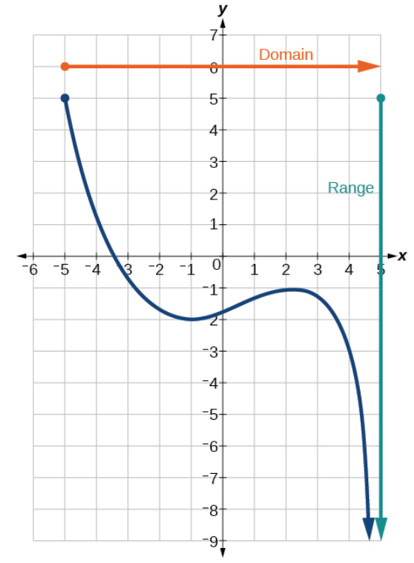To find domain: Read a graph from **left to right** and focus on the $x-$ values.

Domain of Graph:

To find range: Read a graph from **bottom to top** and focus on the $y-$ values.

Range of Graph:

Examples: Find the domain and range of each function below using interval notation.

